**Docker Installation Steps:**

1. a) You can start the docker by clicking the desktop icon and once you start docker application you will get a window and a notification (right bottom) like this.

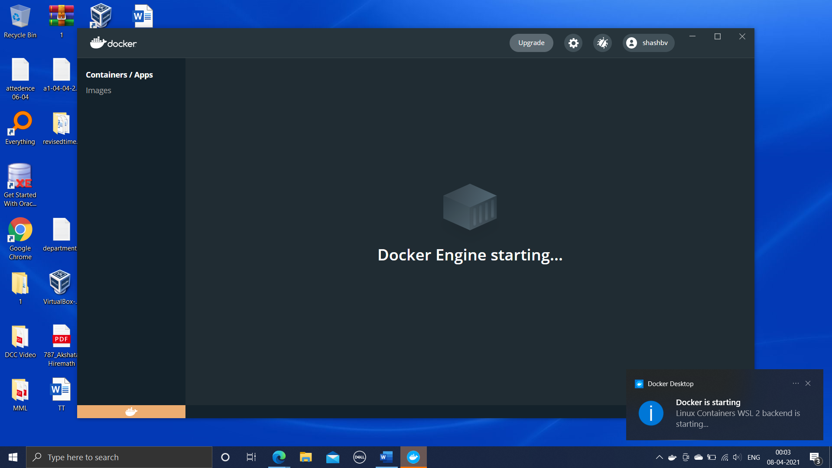

b) Finally, after everything is up and running you will be able to see like this as shown below.

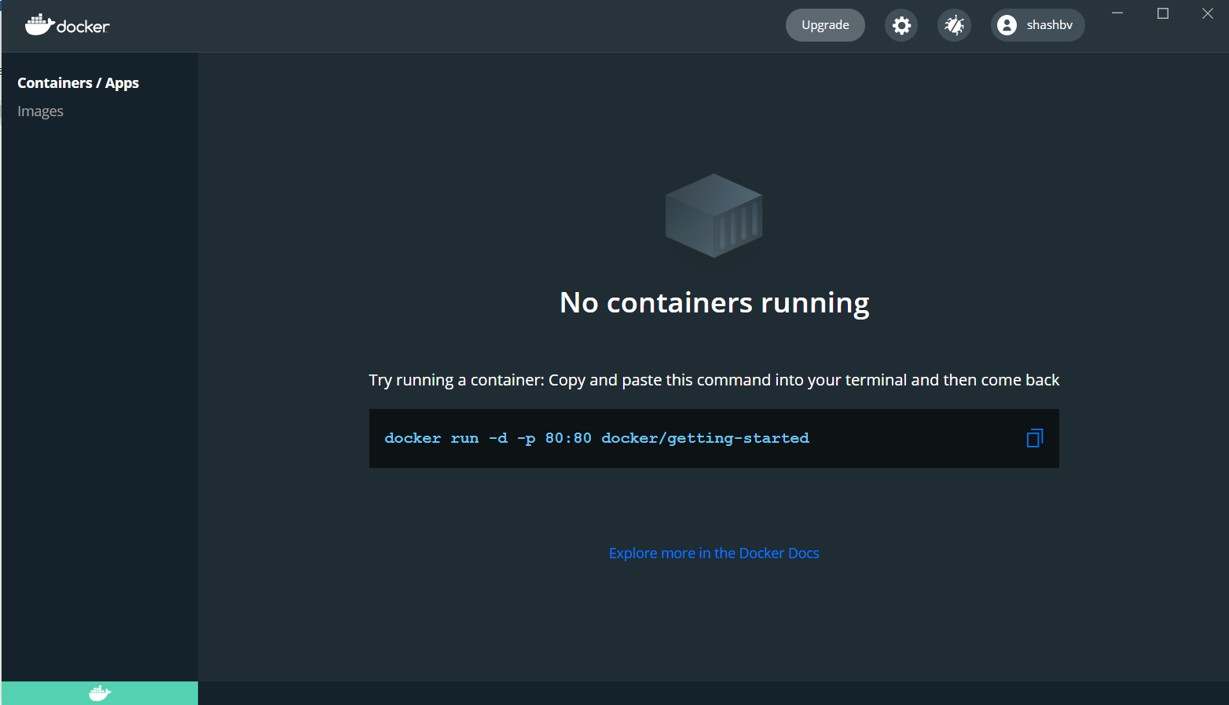

c) On taskbar you can that a docker icon is there which says **“Docker Desktop Running”** one can right click on the icon and explore the further more options.

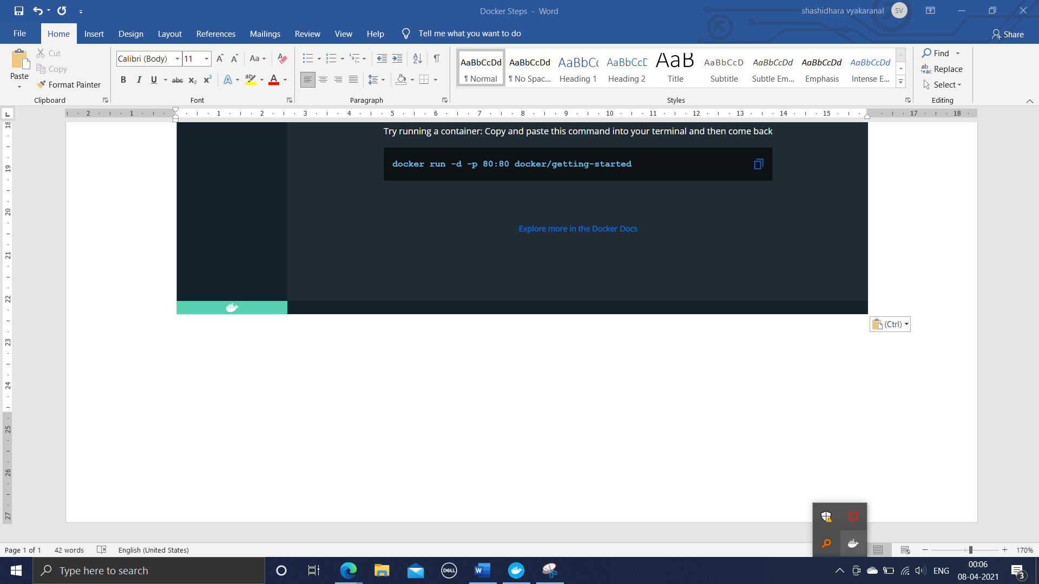

d) One needs to create an account for the usage of docker, can use <https://hub.docker.com/signup> for creating an account once signed up use the credentials for logging to the desktop application.

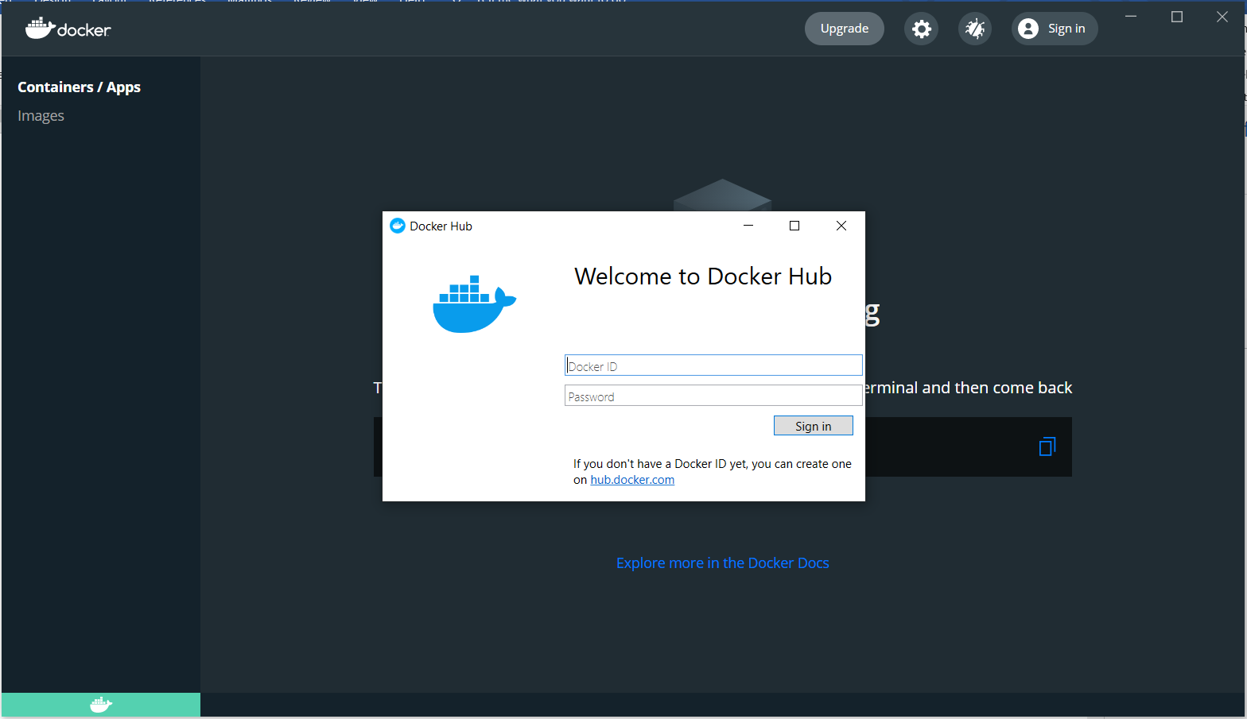

e) once you are ready with your account, we can now start with using the docker.

--------------------------------------------------------------------------------------------------------------------------------------

1. Open Windows PowerShell as an administrator and we can begin with the following commands in the PowerShell terminal.
2. To pull ubuntu image in docker

docker pull ubuntu

1. To view about the image downloaded

docker image ls

1. To create one container

docker run -td ubuntu (here t=terminal and d=daemon)

1. To list the container(s) which are running

Docker container ps -aq (gives information only about Container ID)

OR

Docker container ps -a (gives entire information about Container like time of creation)

1. To run the image that we have downloaded initially

docker exec -it ID /bin/bash (to know your id use above command)

* /bin/bash will help us to get a terminal whose look and feel is same as that of a linux terminal. Once entered that terminal can run any commands which work in linux environment ex: ls, pwd etc.

1. To exit from the /bin/bash

exit (helps to exit from the bash prompt and gets us back to windows prompt)

1. To check list of images installed

docker image ls

1. To remove the image along with container

* First stop the container and the remove the image
* To stop the container first find the container id and then stop the container.

docker ps -a

docker container stop ID

* Remove the container by following command

docker container rm ID

* Remove the image by following command

docker image rm ID

**Website and Webserver using Docker**

1. **To install Nginx server**

docker ps -a (check the list of docker processes)

docker pull nginx (to pull nginx server)

docker image ls (to list the docker images installed)

1. **To start the nginx server (to run nginx container/server )**

docker run -d -p 8000:80 nginx

(d=daemon; p=port; 8000=outside port no; 80=inside port no)

* + To check whether server is working properly not type “localhost:8000” in browser

**OR**

ip address:8000

(to get your ip address, ipconfig in cmd ex : 192.168.2.2:8000)

1. **Now to create an html file in the server’s index.html page location so now we shall enter bash prompt**

docker exec -it ID /bin/bash

* + now let’s navigate to the directory where index.html page is present

cd /usr/share/nginx/html

* + and now make ls it will display the list of directories/folders present
  + exit (Now exit from the bash prompt )

1. **Now to host/load the html file**

pwd

( when you make pwd you will get your present working directory as C:\Windows\system32)

* Now to create a directory/folder in **C:\**

Run the following commands one after another

cd C:\

mkdir myfolder1

ls

cd .\myfolder1\

ls (you will get a empty folder, now place the html file in the myfolder1)

1. **Now run the nginx server using the following command**

docker run -td -p 8000:80 -v C:\myfolder1\:/myfolder1/ --name webserver nginx

(\:/myfolder1 🡨 is the root folder where similar to index.html file is stored)

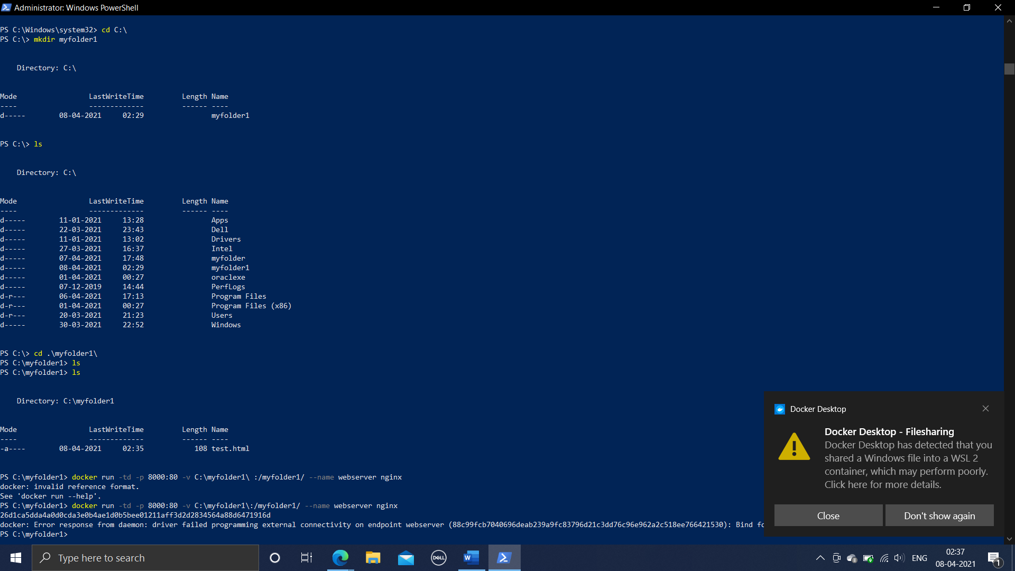

You will get a message as shown in the right bottom of the above image.

**Step 6: Now run the following command to enter the bash mode**

docker exec -it ID /bin/bash

cd myfolder1

ls

**Step 7:** **To copy the test.html file from myfolder1 to nginx server**

cp test.html /usr/share/nginx/html (to execute this we need to be in myfolder1)

* + To check the working of test.html file on nginx server, type the below url in browser

localhost: 8000/test.html

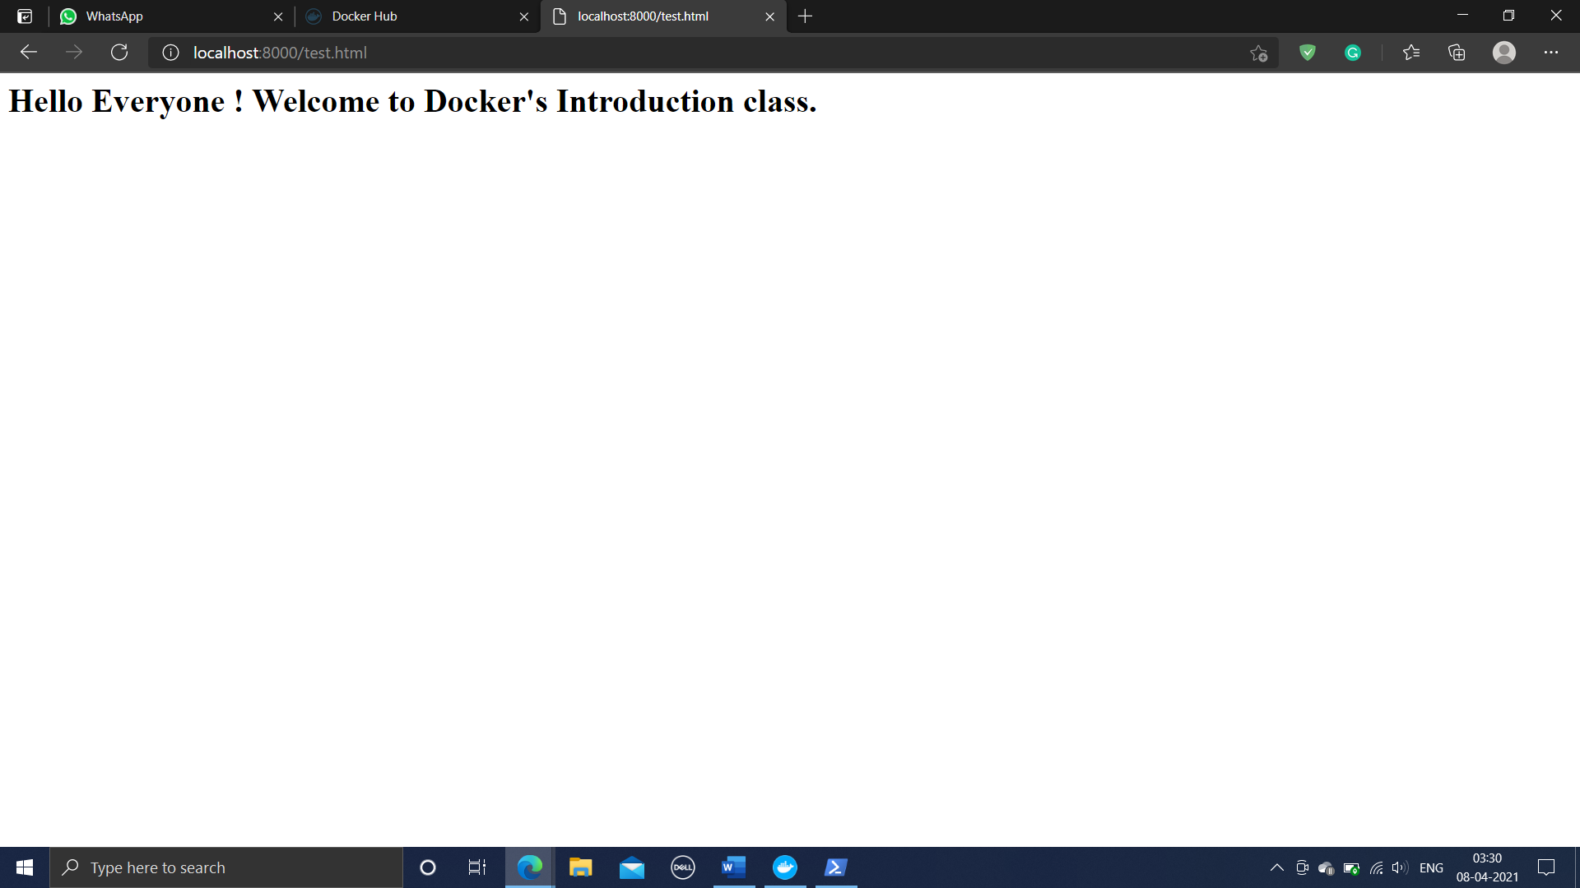

**Note: If you make any changes to the test.html file and if you want to see the changes to reflected then you need to repeat Step 7 completely.**

**Step 8:** exit

--------------------------------------------------------------------------------------------------------------------------------------

**To save the container**

**Step 1: Commit the container created**

docker commit webserver userid/mywebserver:latest

**Step 2: Now push the container your hub (hub.docker.com)**

docker push userid/mywebserver:latest

* Now visit hub.docker.com with your account being signed in. Pushed container application is visible in the hub.

--------------------------------------------------------------------------------------------------------------------------------------

**To reuse the saved container from repository**

**Step 1: Now we shall remove the old nginx that we had pulled and we shall use the one which we created now**

docker container stop ID

docker container rm ID

docker image ls

docker image rm ID

docker images ls

Step 2:

* Pull the container/image from your favorite repository

docker pull userid/mywebserver:latest

* After pulling image, check whether the image has come properly

docker image ls

* docker run -td -p 8000:80 --name webserver userid/mywebserver
* **Now go the browser type in url.**